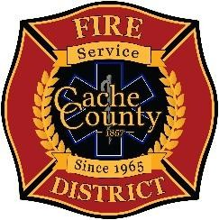
CACHE COUNTY FIRE DISTRICT
BOARD OF TRUSTEES
Kathryn Beus – Board Chair George Daines – Trustee
David Erickson – Trustee Kris Monson – Trustee
Lyndsay Peterson – Trustee Stephanie Miller – Trustee Larry Jacobsen - Trustee

BOARD OF TRUSTEES WORKSHOP AGENDA
November 25, 2025
2:00 pm

The Cache County Fire District Board will meet Tuesday, November 25, 2025, commencing at 2:00 p.m. in the Cache County Historic Courthouse, Council Conference Room, 199 North Main Logan, Utah 84321.

- CALL TO ORDER

- WORKSHOP DISCUSSION
This workshop is designed for all current and newly elected city mayors. Its purpose is to provide information and answer questions regarding the history and current operations of the Cache County Fire District.

- ADJOURN

In compliance with the Americans with Disabilities Act, individuals needing special accommodations (including auxiliary communicative aids and services) during this meeting should notify Janeen Allen, at 755-1850 at least three working days prior to the meeting.

